SOURCE CODE

CI/CD Deployment for SpringBoot Application

BY PRATULYA TIWARY

Contents.

1. GitHub Link… 3
2. Flow Chart… 3
3. Folder Structure 5
4. Project Files… 6

# GitHub Link

|  |  |
| --- | --- |
| Repository Name | Phase-5-CI-CD-Deployment |
| GitHub Link | https://github.com/codorhythm/CI-CD-phase-5- |

## Host server app to view the deployed application: http://3.91.182.20:7000/

# Flow Chart.

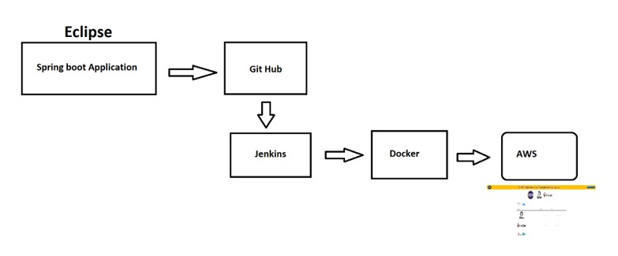

# Folder Structure.

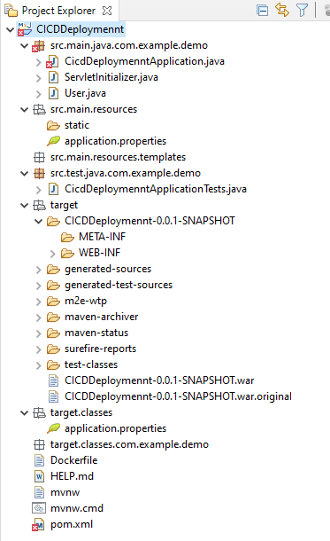

* In Eclipse create a new project by choosing File > New > Spring Starter Project.

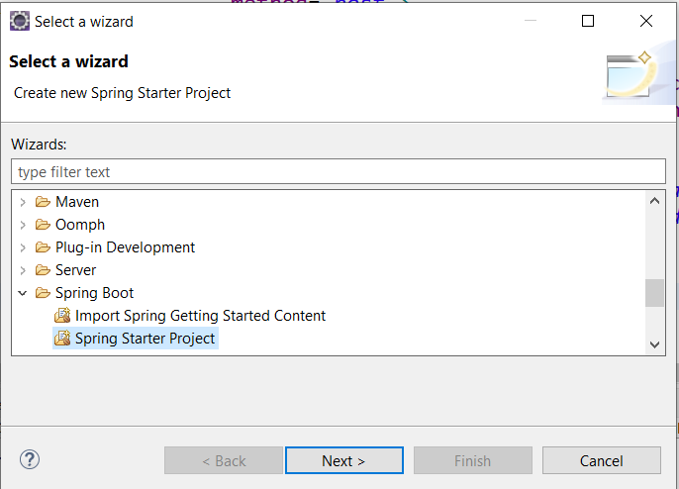

* The Configure your new project as a Spring Web and finish

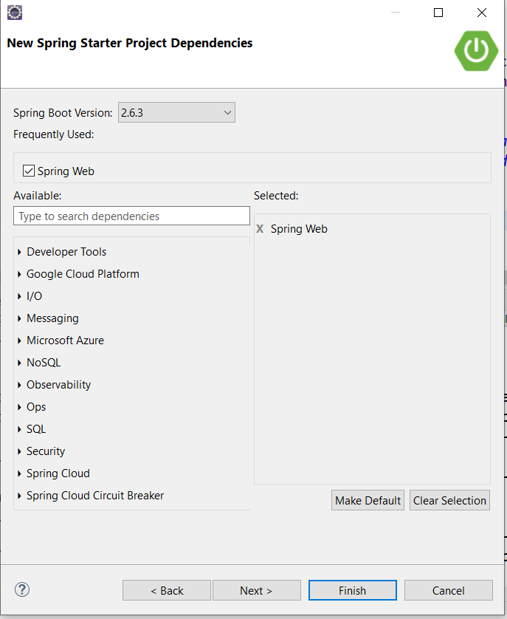

* + After programming the Spring Boot Application using maven to build the WAR file.

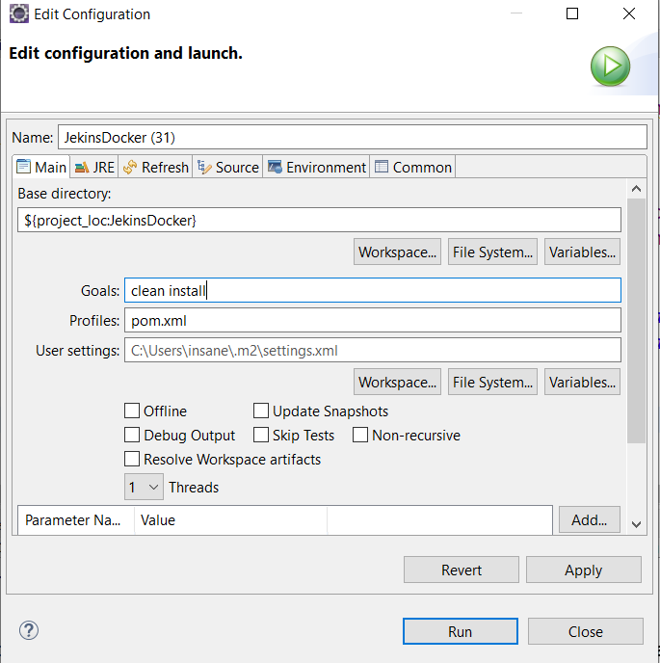

# Project Files.

### Docker File.

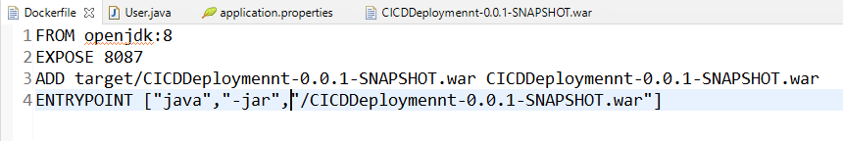

#### Users.java

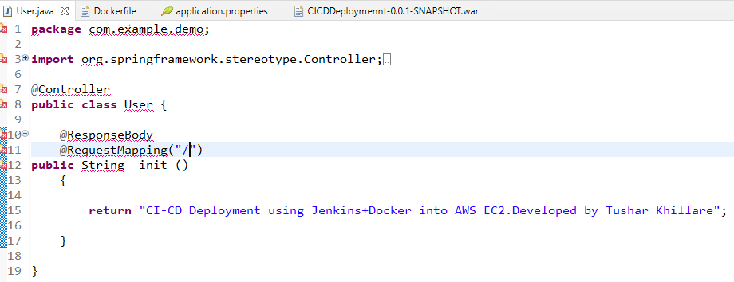

### Application Properties

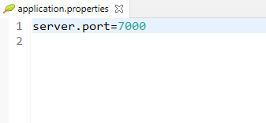

### Pom.xml

